Critique Paper #1
Chad Hamilton
EDIT 720
February 15, 2020

Math Antics is a series of mathematics videos created by Rob and Jeremy of Math Plus Motions, LLC. These videos can be found on YouTube and some educational sites such as Edpuzzle. Each video is an information illustration/narration of mathematical concepts. These videos can be used as supplements to educational instruction. Each video gives students the concepts and steps needed to master and grasp the concept at hand. The video of context is called Math Antics Circles, Circumference, and Area and can be found at https://www.youtube.com/watch?v=O-cawByg2aA.
In terms of multimedia and learning theories Math Antics does a great job at meeting all principles and applying theories. There is one aspect that could be improved. This will be discussed, and a recommendation will be given to help.
Math Antics by Rob and Jeremy does a great job of reducing extraneous processing. According to Kalyuga (2011) extraneous cognitive “results from insufficient learning knowledge base or instructional guidance, an overlapping knowledge base and instructional representations that are separated in space and/or time”. The decrease in extraneous processing through Math Antics allows for easy cognitive processing. This facilitates the learners’ transition from sensory memory to working memory, and finally to long term memory. The components of reducing extraneous processing is using the following principles coherence, signaling, redundancy, spatial contiguity, and temporal contiguity.
The signaling principle states “people learn more deeply when cues are added that highlight the main ideas and organization of the material” (Mayer, 2014). Math Antics multimedia video utilizes the signaling principle through the entire video (see examples thorough image 1 and image 2). It is vital to bring attention to the key items so that the learners’ attention is guided to the relevant/important information being given.
In mathematics, one would think it is effective to have animation, narration, and on-screen text with multimedia. This would go against the redundancy principle which states “people learn more deeply from animation and narration than from animation, narration, and on-screen text” (Mayer, 2014). For example, in the video from Math Antics, the formula is written in text on screen for circumference, with animation of what the formula measures, and narration of how to utilize the formula. In this sense it is necessary and not necessarily redundant. This can be seen in image 3, except for the narration portion.
Incorporating printed words and graphics close to each other makes up the spatial continuity principle (Mayer, 2014). Deeper understanding can take place when this principle is met. Math Antics seamlessly incorporates the printed words and graphics in a way that is conducive to better understanding and ease of connecting the two cognitively. Formulas are given along with images near to further simplify or bring better understand (see image 4).
Along with incorporating the spatial continuity Math Antics utilizes graphics and narration simultaneously. This aligns with the temporal contiguity principle. It would be distracting to have graphics and narration presented back to back. Again, this multimedia tool does an outstanding job at reducing extraneous processing.
The next section discussions the aspect of managing essential processing. This is broken into four components: segmenting, pre-training, modality, personalization, and voice principle. One of these components needs to be implemented more in the video.
Math Antics’ multimedia video is segmented perfectly. The paced is conducive to student learning. It is set up in chunks with processing time also. Driscoll affirms “working memory capacity may be increased through creating larger bits known as chunking”.
Pre-training could be considered activating prior knowledge. (Ausubel, 1965) exclaims an emphasis should be placed on activating prior knowledge to reduce cognitive overflow. At the begging of the video from Math Antics there is a 12 second narration of what was discussed in the previous video. If one had not seen the first video, they would not have any prior knowledge to activate. Math Antics could do a better job incorporating more activation of prior knowledge by demonstrating the basics needed to easily understand/grasp the concept at hand. Since this is a multimedia video one could use more narration and animation to explain what was taught previously so that someone who has not seen the previous video would not be lost.
The modality, personalization, and voice principle all are instilled within the video from Math Antics. The use of graphic and narrations, words are narrated in normal voice and conversation style leading to better understanding.
All in all, Math Antics video on Circles, Circumference, and Area is a good multimedia product. It thoroughly incorporates the multimedia principles within the video with exception of one aspect that needs to be incorporated more, which is the pre-training principle. Recommendations were given to help incorporate.

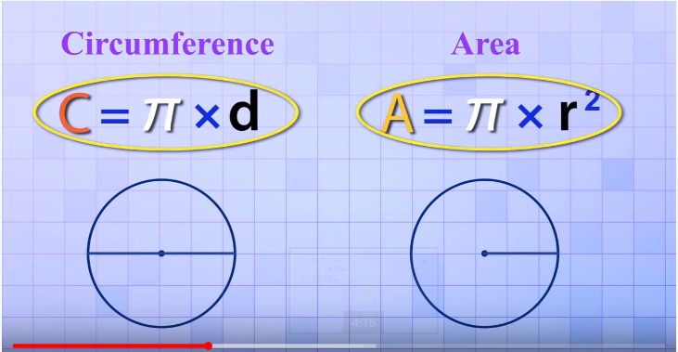

(image 1) Signaling use of circling key points

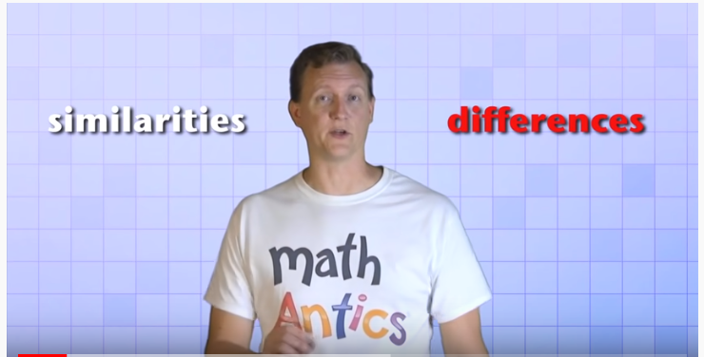
(image 2) Signaling using different colors

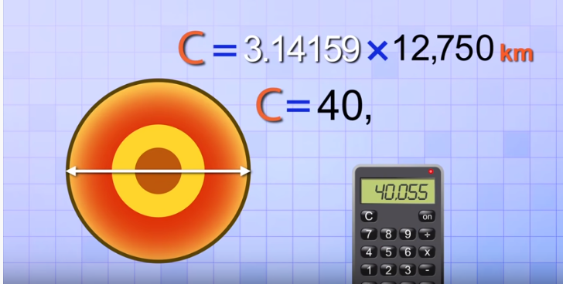
Image 3 (redundancy principle uses of animation, narration, and on-screen text)

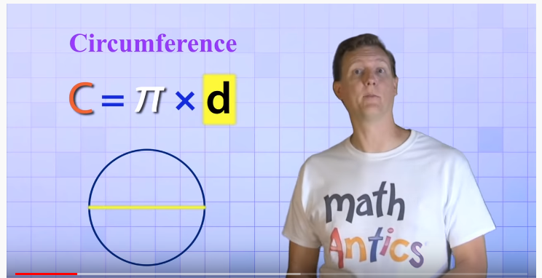
image 4 (Spatial Contiguity Principle, printed words and graphics are placed near)

References
Driscoll, M. (2005). Meaningful learning and schema theory. Psychology of Learning for Instruction (3rd ed.) (pp. 111-152). Boston, MA: Allyn and Bacon.
Kalyuga, S. (2010). Schema acquisition and sources of cognitive load. In J.L. Plass, R. Moreno, & R. Brünken, Cognitive Load Theory, 48-64. New York: Cambridge.
Math Antics. (2014). Circle, Circumference, and Area. Retrieved https://www.youtube.com/watch?v=O-cawByg2aA
Mayer, R. (2014). Research-based principles for designing multimedia instruction [handout]. University of California Santa Barbara, Santa Barbara, CA.

